Microsoft Fabric
Topics
- Workspace
- Lakehouse
- Warehouse
- ADF
- Dataflow Gen2
- Spark Notebook
- Event House
- Event Stream
- KQL
- Semantic Models
- Power BI Reports/Dashboards/Apps
- Stream Dashboard
- Shortcuts
- Mirroring
- Cosmos DB
- Database
- Deployment Pipelines
Practical guide step by step

Workspace

Folders

Views (List vs Lineage)

Workspace settings

Licenses

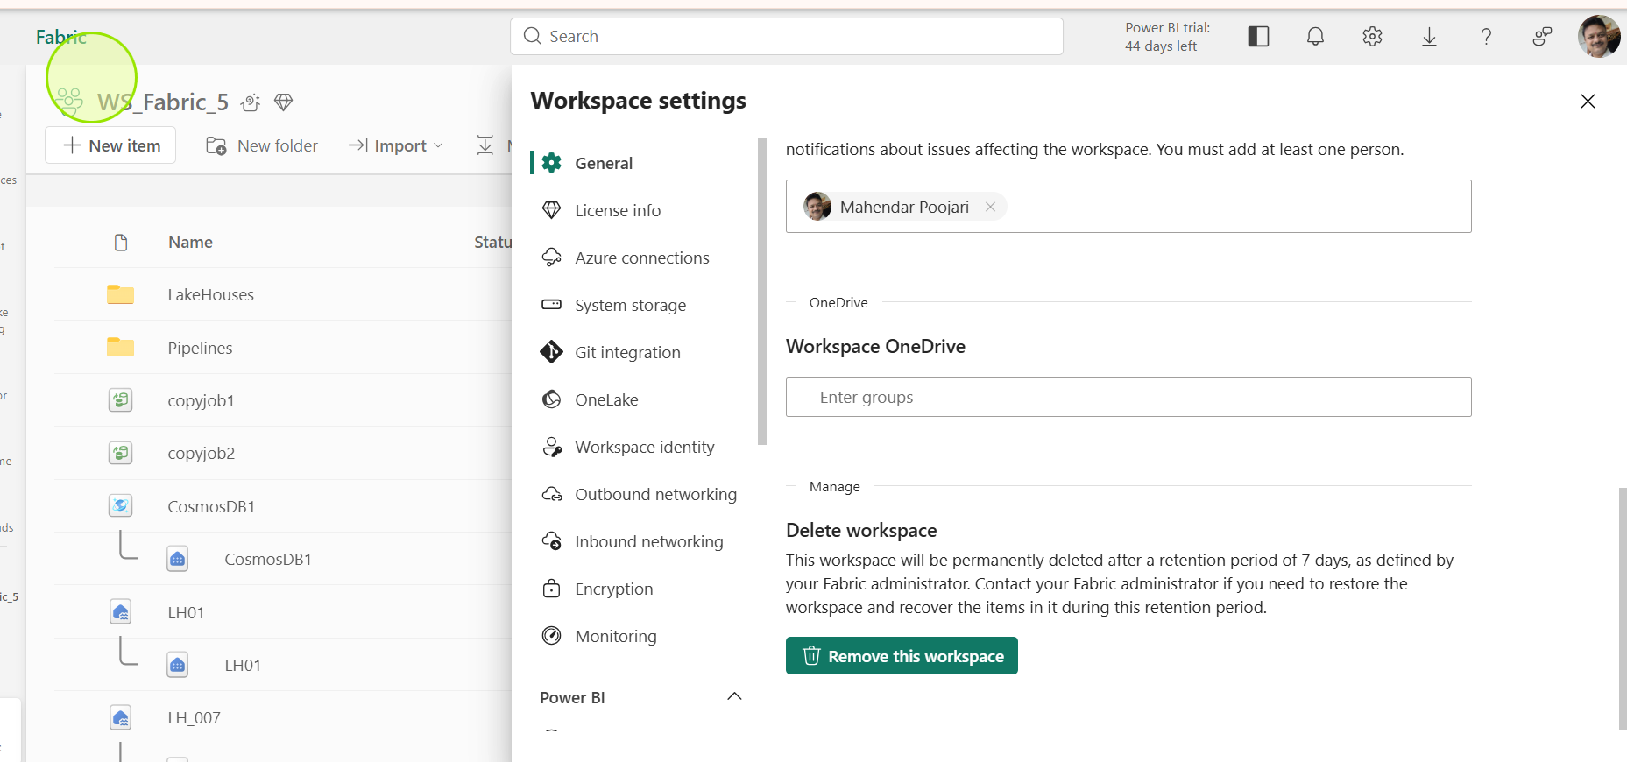

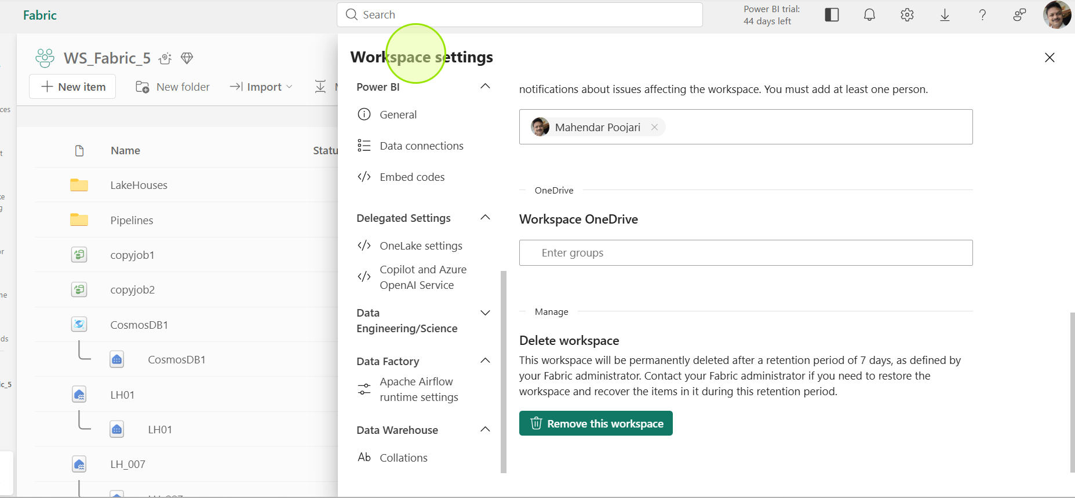

Workspace Access
Workspace Roles
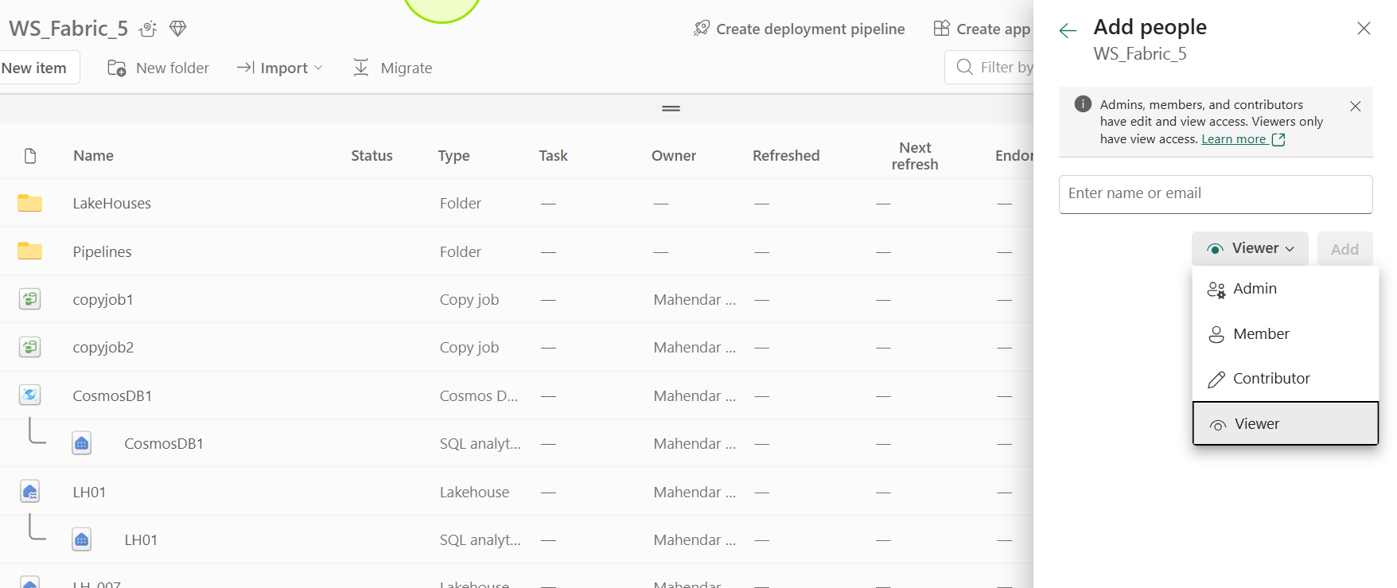

Task View

Lakehouse

Upload file
  - Csv –> load table –> sql to query table –> visual query –> save view
  - Json – cant load to table – DataflowGen2 – load to table ->
  - Multiple files – Copy job (f2f), Tables to tables

  - Folder
SELECT Item, SUM(Quantity * UnitPrice) AS Revenue
FROM sales
GROUP BY Item
ORDER BY Revenue DESC;

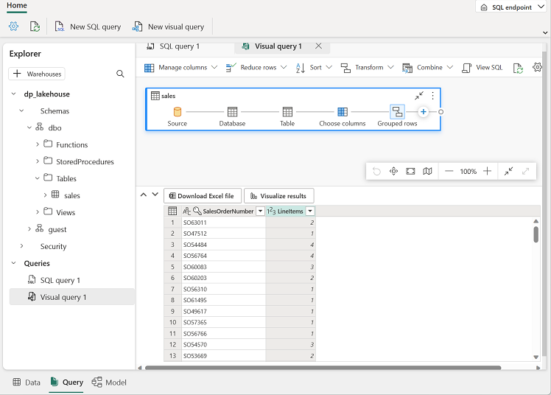

ShortCut
Work with Sample

ADF
File 2 file
Table 2 table
Copy job relative path wildcard
File process based on the name
Copy Job
Copy data
Get metadata
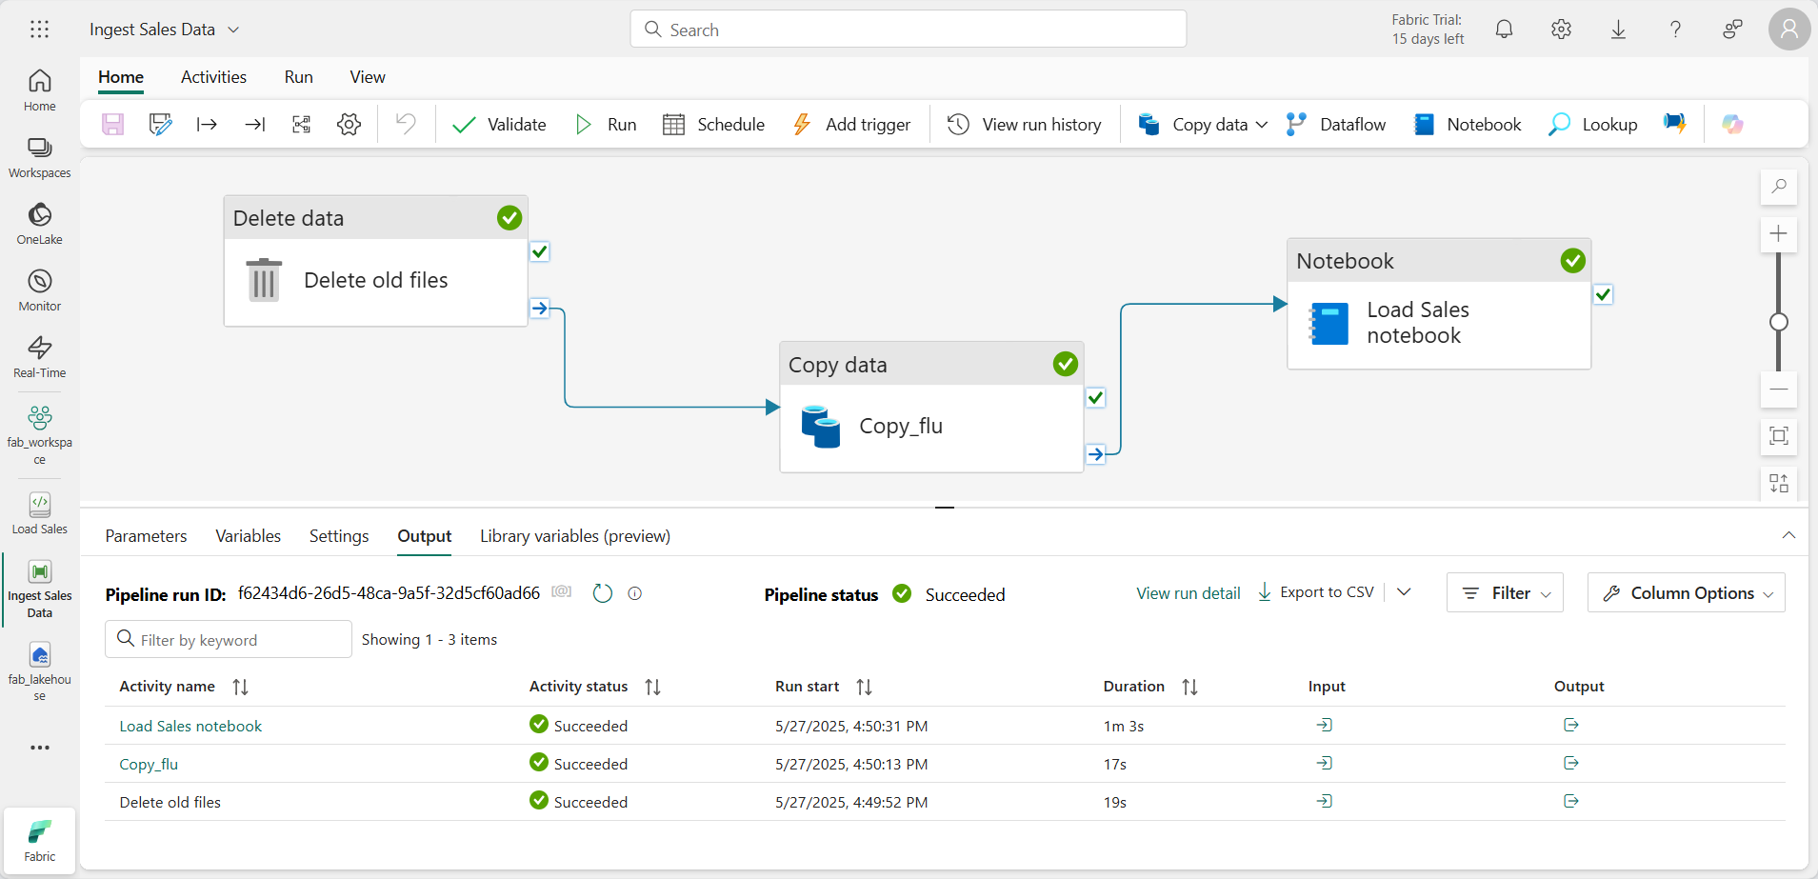

Data Movement Activities
- Copy Activity
Moves data from a source to a destination (e.g., from SQL DB to Blob Storage).

Data Transformation Activities
- Data Flow
Performs transformations at scale using mapping data flows.
- HDInsight Hive Activity
Runs Hive queries on HDInsight clusters.
- HDInsight Pig Activity
Executes Pig scripts.
- HDInsight Spark Activity
Runs Spark jobs.
- HDInsight MapReduce Activity
Executes MapReduce programs.
- Stored Procedure Activity
Calls stored procedures in a database.
- Databricks Notebook Activity
Executes Databricks notebooks.
- Azure Batch Activity
Runs custom scripts on Azure Batch.

Control Flow Activities
- Execute Pipeline
Invokes another pipeline.
- ForEach
Iterates over a collection of items.
- If Condition
Executes activities based on a Boolean expression.
- Switch
Executes activities based on matching a value.
- Wait
Pauses pipeline execution for a specified time.
- Until
Loops until a condition evaluates to true.
- Append Variable / Set Variable
Manipulates pipeline variables.

External Activities
- Web Activity
Calls REST endpoints.
- Lookup Activity
Retrieves data from a source for later use.
- Get Metadata Activity
Fetches metadata of a dataset.
- Validation Activity
Validates the existence of data before processing.

Dataflow Gen2
Power Query

Notebook

Apache Spark
Step 1: Basics
Before diving into Fabric, you need a solid grasp of Pyspark fundamentals
What is Apache Spark?
Pyspark is the python API for Apache Spark, a distributed computing framework for big data processing
Why spark? Why distributed computing?
Apache Spark is designed for big data processing. Traditional tools like pandas or SQL databases struggles
When:
Data is too large to fit in memory
Needs to process TB or PB(Petabytes) of data.
Spark solves this by:
Distributed processing:
n-memory computation: Faster than disk-based systems like Hadoop MapReduce.
Unified engine: Handles batch, streaming, machine learning, and graph processing.
Why Distributed Computing?
When data grows beyond a single machine’s capacity:
Storage limits: A single server can’t hold all the data.
Compute limits: Processing billions of rows on one CPU is slow.
Distributed computing:
Splits data into partitions across a cluster.
Executes tasks in parallel on multiple nodes.
Reduces processing time from hours to minutes.
Example Scenario
Imagine you have 1 TB of logs:

On one machine: Might take 10 hours.
On a Spark cluster with 10 nodes: Could finish in under 1 hour because each node processes a chunk in parallel.

Spark Architecture Driver, Executors, Cluster Manager
Pyspark vs Scala spark
Python essentials for data ( lists, dictionaries, pandas basics)
Data types, file formats (CSV, Parquet, Delta)
Spark Sessions & RDDs
Create Spark session in Fabric
RDD basics: map, filter, reduce
Dataframs & Spark SQL
Create Dataframes from csv, parquet, Delta
Transformations select, filter, group by, join
Actions: Show, collect, count
Register temp views and run queries
Phase 3: Fabric Integration
Understand Lakehouse architecture in Fabric
Read/Write data from onelake using pyspark
Use delta format for ACID transformations
Fabric Spark notebooks
Create
Attach
Schedule notebooks in Fabric pipelines
Phase 4: Advanced Pyspark
Performance optimization
Partitioning and bucketing
Caching and Persistance
Broadcast joins
Detla lake features
Time travel
Merge upsert operations
Optimize and Vaccum
ML & Streaming
Use MLlib for machine learning
Structured Streaming basics
Integration with Azure ML
Production & Best Practices
CI/CD & Governance
Version control notebooks
Data Security & Permissions in Fabric
Monitoring Spark Jobs

Core concepts
RDDs(Resilient Distributed Datasets)
Dataframes
Transoformation vs actions
Spark SQL
Step 2: Microsoft Fabric context
Fabric uses Lakehouse architecture and supports spark notebooks for data engineering and analytics. Key Points.
Fabric provides Onelake as a unfied data lake
Run Pyspark notebooks inside Fabric for ETL, data prep, and ML
Integration with Power BI for Visualization.
Step 3: Hands-On in Fabric
  - Create lakehouse in Fabric
  - Open a Spark Notebook
  - Write Pyspark code to:
    - Load data from Onelake or External sources
    - Transform data using Spark DataFrames.
    - Save Processed data back to Lakehouse tables.
Example
df = spark.read.csv(“Files/mydata.csv”, header = True, InferSchema = True)
df_filtered = df.filter(df[“status”] == “active”)
Step 4: Advanced topics
Delta Lake in Fabric ( for ACID transactions)
Optimizing Spark jobs ( partitioning and caching)
Integration with ML frameworks ( MLlib, Azure ML)
Scheduling notebooks in pipelines
Step 5: Practice
Start with small datasets in Fabric
Explore Spark SQL for querying
Try dataframe API for transformations

File read
File write
File read – write to table
Dataframe
Add column
Joins
Magic commands
Commenting
- Basics of Fabric Notebooks (UI, languages, execution)
- Lakehouse Integration (read/write Delta tables)
- Data Exploration & Transformation (Spark DataFrames, Spark SQL)
- Delta Lake & Versioning (time travel, optimize)
- Visualization (built-in charts, Matplotlib, Plotly)
- Machine Learning in Fabric (MLlib, integration with Azure ML)
- Performance Optimization (partitioning, caching)
- Integration with Fabric Ecosystem (Pipelines, Power BI)
- Security & Governance (permissions, compliance)
- Parameterized Notebooks (dynamic execution with widgets & pipeline parameters)

Tables
Delta tables
Managed Tables
External Tables

Files
Parquet files
Csv files
Json files
Excel files

Warehouse
Load sample data

Eventhouse

Event stream

KQL
Real-time dashboard
KQL Tutorial: Beginner → Advanced
Introduction to KQL
- What is KQL?
  - A read-only query language for Azure Data Explorer, Log Analytics, Application Insights, Microsoft Sentinel.
  - Optimized for log analysis, telemetry, and time-series data.
Key Features
- Pipe-based syntax (|) for chaining operations.
- Fast, scalable, and columnar.
Basic Query Structure
TableName
| where Timestamp > ago(1d)
| project ColumnA, ColumnB
| summarize Count = count() by ColumnA
| order by Count desc
|

Mirroring

Beginner Level

Filtering Data
TableName
| where Level == "Error"
| where Timestamp > ago(7d)
| where Message contains "timeout"

Select Columns
TableName
| project Timestamp, Message, Level
Sorting and Limiting
TableName
| order by Timestamp desc
| take 50

Intermediate level

Aggregation
Tablename
| summarize count = count() by level
| summarize avgDuration = avg(DurationMs) by bin(Timestamp, 1h)

Time bucketing
TableName
| summarize count = count() by bin ( Timestamp, 1h)

Joining tables
TableA
| join TableB kind = inner on keycolumn

Deduplication
TableName
| summarize arg_max(Timestamp, *) by sessionId

Advanced Level

Parsing JSON
TableName
| extend payloadObj = parse_JSON(Payload)

REGEX Extraction
TableName
| extend user = extract(@”user=(\w+)”, 1 , Message)

Conditional Logic
Tablename
| extend Severity = case(Level == “Error”, 3, Level = “Warning”, 2, 1)

Time Series Analysis
TableName
|make-series count = count() default = 0 on Timestamp from ago(24) to now() step 1h

Visualization
TableName
| summarize count = count() by bin(timestamp, 1h)
| render timechart

Real-World Examples

Top 5 Errors in Last 24 Hrs
Apptraces
| where timestamp > ago(24h)
| where severityLevel == “Error”
| summarize count = count() by message
| sort by count desc
| take 5

Slow request by Operation
AppRequests
| where timestamp > ago(7d)
| summarize p95 = percentile(DurationMs, 95) by Name
| order by P95 desc

Reusable Variables – Let
Let timeframe = 24h
Let CriticalLevels = dynamic([“error”, “Critical”]);
Logs
| where timestamp > ago(timeframe)
| where Level in (CriticalLevels)

Query Structure & Basics
TableName
| where timestamp > ago(1d)
| project ColumnA, ColumnB
| summarize count = count() by ColumnA
| sort by count desc

Filtering – Where
TableName
| where level == “Error”
| where Status in (“failed”, “Timeout”)
| where DurationMs > 1000
| where message contains “timeout”
| where message has “timeout”
| where message !contain “debug”
| where isnotempty (userID)
| where timestamp between ( datetime(2025-12-01).. datetime(2025-12-12)

Column Selection – Project, project-away, project-rename
Tablename
| project Timestamp, Level, Message
| project-away Rawpayload, LargeBlob
| Project-rename Severity = level, Time = timestamp

Create / Transform Columns – extend
Tablename
| extend Hour = datetime_part(“hour”, Timestamp)
| extend IsSlow = DurationMs > 100
| extend Host = tostring(parse_url(URL).Host)
| extend NormalizedUser = tolower(UserID)
Aggregation – Summarize
TableName
| summarize count = count()
| summarize DistinctUsers = dcount(UserID)
| summarize AvgDuration = avg(DurationMs)
| summarize P95 = percentile(DurationMs, 95)
| summarize Total = sum(Bytes), Max = Max(Bytes)
| summarize Count = count() by Level
| summarize count = count() by bin(Timestamp, 1h)
Use make-series for time-series with missing intervals
TableName
|where timestamp > ago(24h)
|make-series count = count() default=0 on Timestamp from age(24h) to now() step 1h

Sorting and Limiting – order by, sort by, take, top
TableName
| order by Timestamp desc
| take 100
| top 10 by durationMs Desc

Joins – Join, Lookup, union
TableA
| join kind = inner TableB on Id
TableA
| join jind = leftouter tableB on Key
TableA
| lookup kind = leftouter tableB on UserId

Performance Tips

Use has instead of contains for tokenized columns.
Drop unnecessary columns early with project-away.
Use lookup for small reference tables.
Reduce rows before joining.

Skill Areas in KQL
Skill Area | Description
Basic Query Syntax | Where, project, extend, chaining via
Filtering and Searching | Contains, has, in, between, timefilters
Aggregation and Summarization | Summarize, count, avg, percentiles, dcount, bin()
Sorting and limiting | Sort by, order by, take, top
Time series Analysis | Make-series, render timechart, bin()
Joins and enrich | Joins, lookup, union

Database
Monitoring Database
What is Monitoring in Fabric?
Monitoring in Fabric means tracking Query Performance, Resource Utilization, and data refresh activities across your fabric Items ( Lakehouse, warehouse, dataflows, pipelines)
It helps in :
Detect slow queries
Optimize compute usage
Ensure data refresh reliability
Maintain compliance and auditing
    - Fabric Monitoring Hub
Central dashboard for all work loads
Shows capacity metrics, refresh history and resource consumption.
    - SQL Analytics End Point
For Warehouse or SQL Endpoint
Provides,
Query execution time
CPU/Memory usage
Query plan for optimization
    - Activity Monitoring
Tracks dataflows, pipelines, and refresh schedules
Useful for ETL performance and troubleshooting.
    - Capacity Metrics
If Workspace it Premium or dedicated Capasity, you can monitor,
CPU Utilization
Memory Pressure
Concurrency limits
How to enable and use monitoring?
Go to Admin Portal Monitoring Hub
For Warehouse
. Use query insights to view query performance.
Enable diagnostic settings to export logs to Azure Monitor or log Analytics.
For Lakehouse
Monitor spark execution via Spark UI
Check job duration, shuffle size and executor memory.
Best Practices:
Set alerts: Use Azure Monitor integrate for alerts on high cpu usage or failed refresh.
Analyze Query plans: Identify bottle necks like missing indexes or large scans.
Capacity planning: Monitor usage trends to avoid throttling
Log Retention: Export logs for long term Analysis and compliance.

difference between a SQL Endpoint and a Warehouse in Microsoft Fabric:
  - SQL End point
Purpose: It provides a read-only T-SQL interface to query data stored in lakehouse(Delta tables in lakehouse)
Underlying storage : data remains in lakehouse ( files in delta format)
Use case: Ideal for ad-hoc querying, BI tools(Like Power BI) and reporting without moving data.
Characteristics: No separate storage, it’s a virtual layer on lakehouse.
Support T-SQL queries, but limited DML ( no full transactional support)
Great for analytics, not for Heavy OLTP workloads.
Performance: Depends on Lakehouse Compute(Spark Engine).

  - Warehouse:
Purpose: a Dedicated relational database in fabric for structured data with FULL SQL capabilities.
Underlying storage: It stored onelake, optimized for SQL-based analytics.
Use case: Best for Enterprise grade analytics, data modelling and complex queries.
Characteristics:
Full T-SQL support(including DML, constraints, indexes)
Optimized for high-performance queries.
Can serve as a central datawarehouse for BI and reporting.
Performance: Uses fabrics distributed compute engine for scalability.
Features | SQL Endpoint | Warehouse
Storage | Lakehouse(Delta tables) | Dedicated warehouse tables.
Write-support | Limited | Full T-SQL (DML)
Use case | Quick queries, BI Access | Enterprise Analytics
Performance | Spark-based | Optimized SQL Engine

Cosmos DB

Semantic Model

Power BI Report/Dashboard/App

Deployment Pipelines

ADF

Notebook
Pyspark
PySpark fundamentals in Fabric notebooks
Reading and writing to lakehouse
Medalion architecture(Bronze, Silver and Gold)
Dataframe operations and transformations
Aggregations, joins, and windows functions
Data Quality validation
Performance Optimization
Complete ETL pipelines
Fabric Specific features

Microsoft Fabric provides a managed Spark environment with pre-configured notebooks. Unlike standalone pyspark, Fabric Handles
Automatic Spark session management
Integration with lakehouse and delta lake
Workspace and capacity management
Built-in visualizations and monitoring
Onelake as underlying storage
Why use pyspark in Fabric?
Data Transformations in Medalion architecture ( Bronze Silver Gold)
Complex Business logic That SQL cant handle
Machine Learning preparation and feature engineering
Data Quality checks and validation
Custom Aggregations and calculations

Gata Flow Gen2

Medalion architecture

Udemy – Fabric
Fabric Introduction
Architecture
  - Create Workspace
    - License
    - WS Access
    - Setting
  - Lake House
    - Upload csv file
    - Upload another csv file
    - Create a delta table
    - SQL Query join – Save as a view
    - Visual Query – save as a view
  - Semantic Model
    - Get data from semantic model
    - Model view ?
    - Create Measure
Power BI Desktop – get data from semantic model.
Create the report and publish
Create dashboard
Create app

